**1.**

**a.** One-to-Many: the maximum number of instances that are related between two sets is one in one direction and many in the other direction.



**b**. One-to-One: the maximum number of instances that are related between two sets is one in both directions.



**c**. Many-to-Many: the maximum number of instances that are related between two sets is many in both directions.



**2.**

**INTRODUCTION**

Soccer, or more commonly known as Football, is a sport in which two teams of 11 players each compete to score goals in the opposing team’s goal using their feet. The rules allow players to use any part of the body except for their hands and arms. Matches last approximately 90 minutes, divided in two halves, plus variable over time. The

structure of this database is simple to facilitate understanding and writing of solution

queries.

Access to these database tables requires the “Soccer” logon credentials.

**DATABASE MODEL**

The database consists of three tables: Players, Teams, GameStats. The key

symbol indicates which attribute is the key field for the table. The relationship lines indicate foreign keys. There are *200* players in the database.

• Each player may have one team, and each team must have many players.

• Each team must have one or more uniform colors, and each color may be worn by 0 or many teams.

• Each game must have a field, and each field may have 0 or many games.

• Each player may play 0 or many games, and each game must be played by many players.

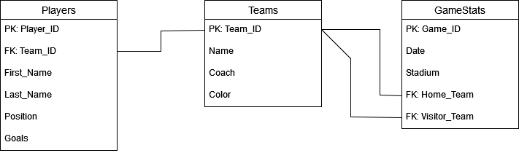

**DATABASE TABLES**

**Players Table**

The Players Table contains basic information about the Players. The key to this table is Player_ID. Other information contained in the table is Player Name, and Position. Finally, the total number of Goals scored for each Player is also listed. There are 33 Players in the database. This table also contains a foreign key which connects the players to the Team Table(Team_ID).

**Team Table**

The Team table contains basic information about the Team, primarily the Team Name, Coach Name and Uniform Color. The key to this table is Team_ID.

**Game Statistics Table**

The GameStats Table contains information for Game Dates, Stadium Name, and Names of the Home and Visitor Teams. The key is Game_ID. There are two Foreign Keys (Home_Team) and (Visitor_Team) which connect to the Teams table (Team_ID).

3.



**4.**

Each EMPLOYEE MUS have 1 or many JOBS

Each JOB MAY have 0 or 1 EMPLOYEE



**5.**

Each PARENT MAY pick up 1 or many CHILDREN or none if their spouse went alone

Each CHILD MUST be picked up by 1 or many (2) PARENTS



**6.**

**a**.



**b.**



**c.**

